Lab # 11: Form Development – Creating List of Values
Subject: Database Systems
Course: BESE-15 B
Date: December 14th, 2010

Create a Master- Detail form. Use employee table data for master data block and department table data for details data block.
A List of Values is based on a Record Group. In Oracle Forms, a record group is a query that returns some collection of records. Record groups can be used to populate blocks or LOVs and they can be used in procedures. When the user navigates to an item with an LOV attached to it, the LOV key (F9 or Ctrl + L) can be pressed to call up the LOV. At that time, the query associated with the record group is executed and the results are displayed in a pop up window.

Creating a List of Values
Creating a List of Values requires 4 basic steps.

Create a new LOV Object
To create an LOV, click on the LOVs node in the Object Navigator. Then pull down the Edit menu and choose the Create menu item. A dialog box will appear asking if you would like to create the LOV manually or if you would like to use the LOV Wizard.
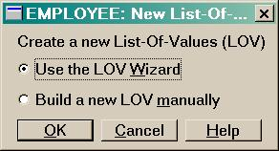
Choose "Use the LOV Wizard" and click the OK button. The first step of the LOV Wizard will appear as below:
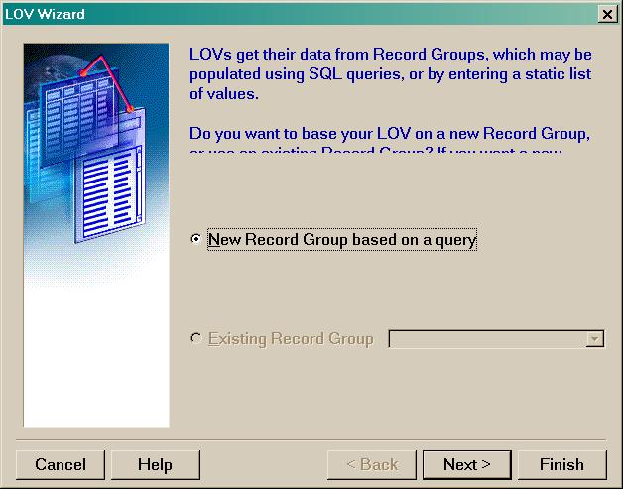
The default is set to create a new Record Group based on a query. Make sure this selection is highlighted and then click the Next button. Enter the LOV query as follows:
SELECT deptno FROM department
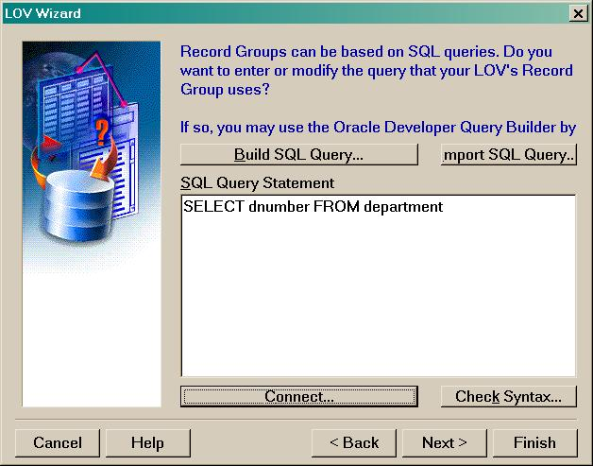
Then click on the Next button.
The next step is to specify which columns in the record group will be returned to for use by the LOV. In this example, we only return DEPTNO so select that column as shown below and click Next.
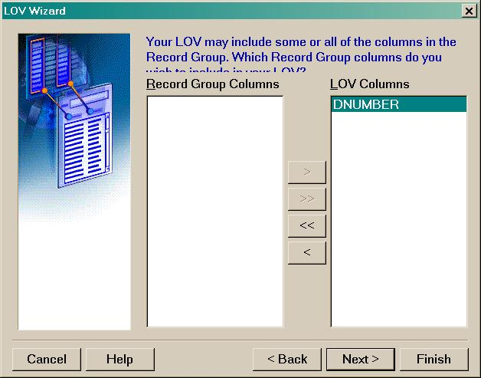
The next step is to specify the display properties of the LOV columns and also to map the LOV item to the field on the form.
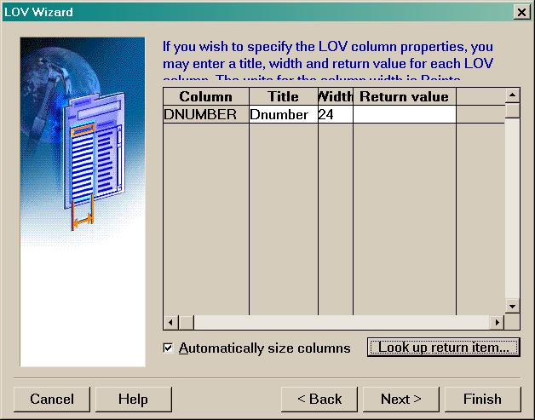
To map the LOV column to a field, click on the DEPTNO entry and then click on the "Look up return Item" button. Highlight the EMPLOYEE.DEPTNO field and click on the OK button.
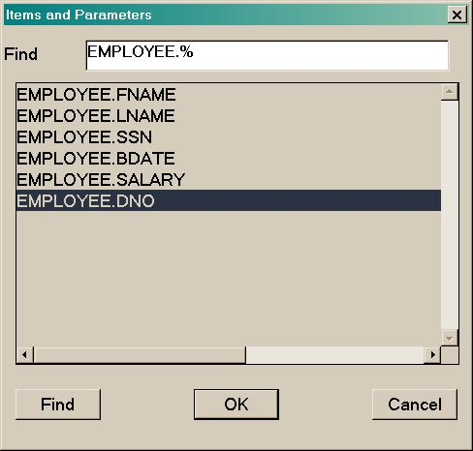
Click on the Next button.
Specify a title for LOV window (e.g., "List of Department Numbers"). At this point you may also specify the size and positioning of the LOV. Better leave them as the defaults and click the Next button.
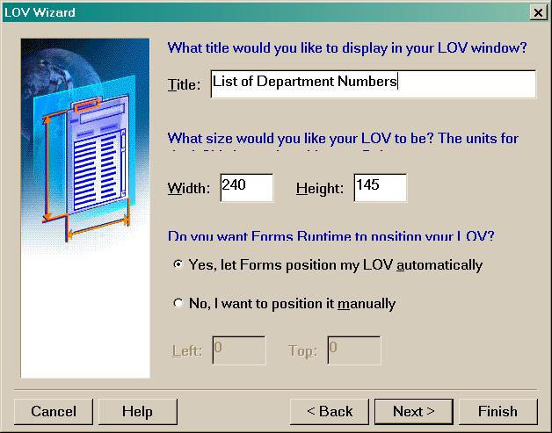
The advanced properties relate to how the records should be fetched for the LOV. If there are many hundreds or thousands of possible records returned by the LOV, you may consider changing these options. Otherwise, for this example, simply click Next.
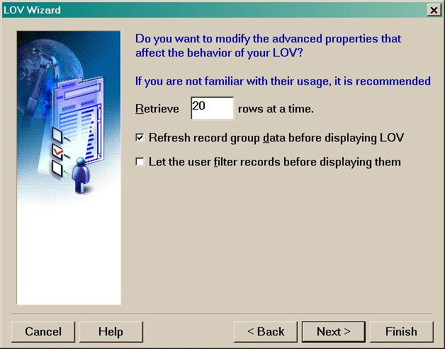
In this final step, the LOV is returning some columns and they were assigned to fields on the form in a previous step. At this point, we need to associate the LOV with a particular item on the form. For example, by assigning the LOV to the EMPLOYEE.DEPTNO field, the user will be able to call up the LOV only when the cursor is positioned in the EMPLOYEE.DEPTNO field. Choose EMPLOYEE.DEPTNO and click the Next button.
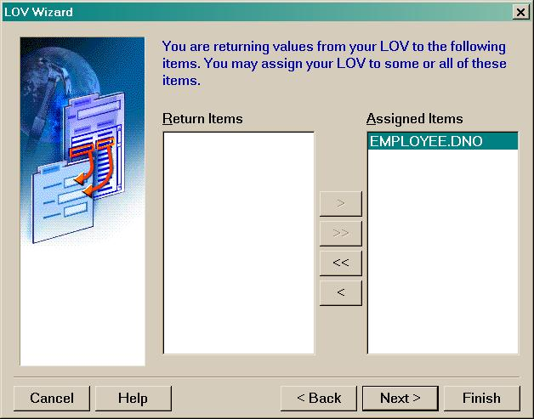
Finally, click Finish to create the Record Group and the LOV.
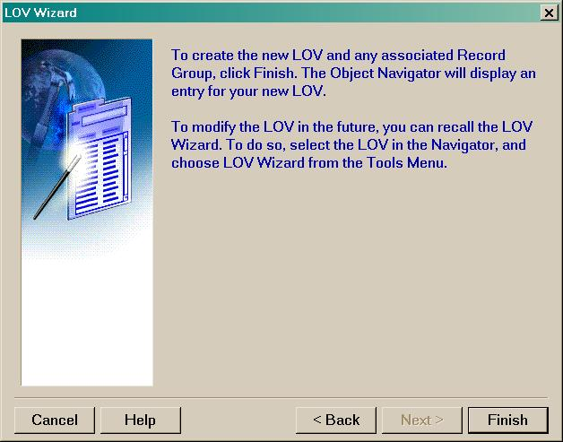
Save, Compile and Run the form. When entering new data, navigate to the DEPTNO (Department number) field. Notice at the bottom of the form, a message appears: List of Values indicating a list of values is available for this field.
Below is an example of the list of values for the DEPTNO item on the Employee form.
